# CS 255 System Design Document Template

## UML Diagrams

### UML Use Case Diagram

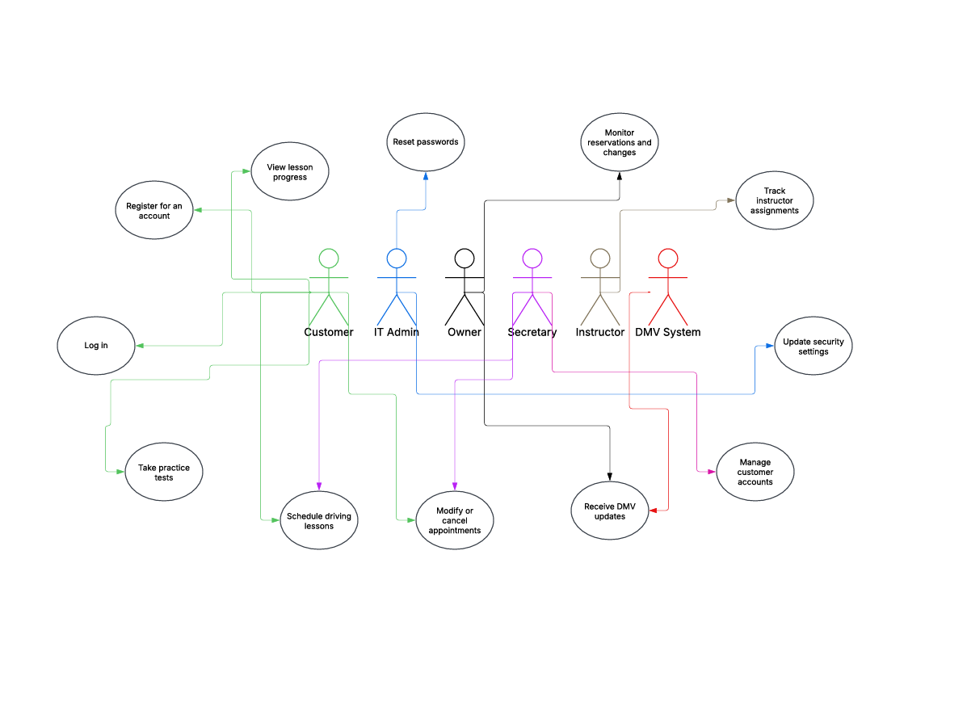

### UML Activity Diagrams

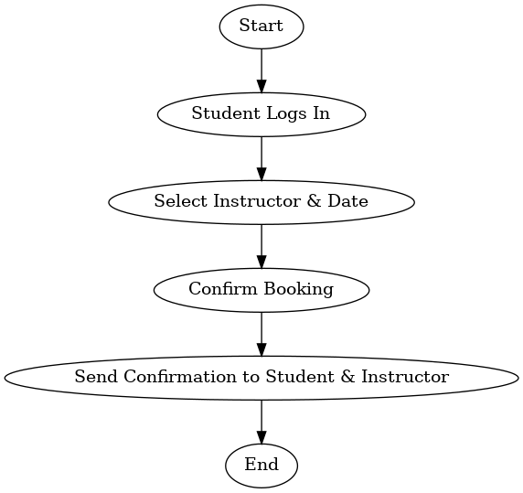

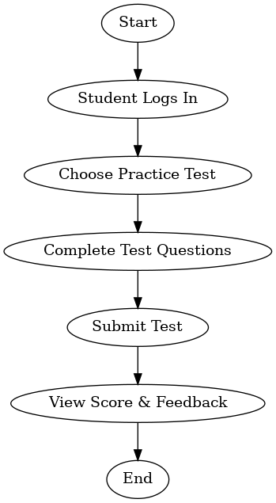

### UML Sequence Diagram

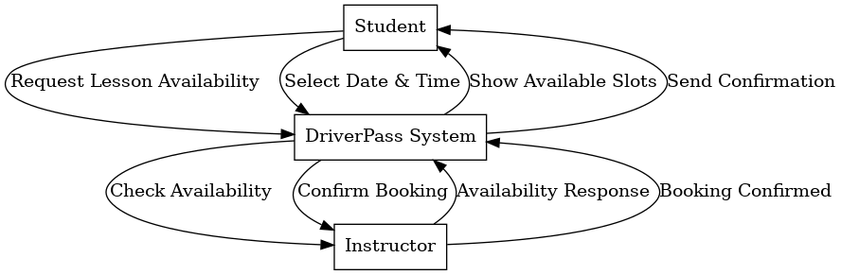

### UML Class Diagram

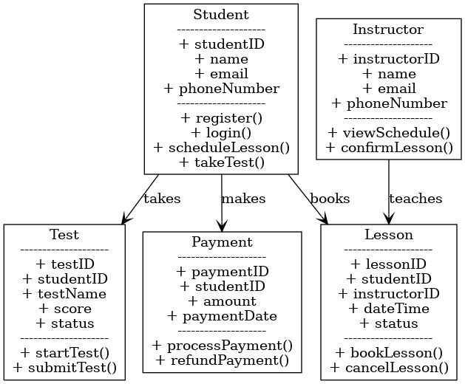

## Technical Requirements

### **Hardware Requirements**

* The system will run on cloud servers like AWS, Google Cloud, or Azure.
* Users can access it from computers, tablets, and smartphones.
* A database will store lesson bookings, test scores, user accounts, and payments.

### **Software Requirements**

* The system will use **Linux (Ubuntu)** or **Windows Server**.
* Data will be stored in a **PostgreSQL or MySQL database**.
* The backend will be built using **Python (Django)** or **Java (Spring Boot)**.
* The front-end will use **React.js or Angular** for the web app and **React Native or Flutter** for the mobile app.

### **Tools & Infrastructure**

* **GitHub** will be used to manage and track code changes.
* **Lucidchart** will help design UML diagrams, and **Confluence** will store documentation.
* The system will use **RESTful APIs** to connect the front-end and back-end.
* Hosting will be handled on **AWS, Google Cloud, or Azure**.

### **Security Measures**

* Users will have different access levels (Admins, Students, Instructors).
* All data transfers will be encrypted using **HTTPS**.
* Passwords and payments will be stored securely using encryption.
* The system will track all user actions like lesson bookings and test submissions.